

ITCS486 Multimedia Data Technologies

Unity 2D Game Project

Space shooter

Submitted by

Pornthipa Khummalai Section 2 ID:6088066

Apichaya Kuama Section 2 ID:6088097

Tanatip Tumsatiansuk Section 2 ID:6088172

Instructor

Dr. Pisit Praiwattana

A report is submitted in partial fulfillment of the requirements for

ITCS486 Multimedia Data Technologies

Faculty of Information and Communication Technology

Mahidol University

Space shooter 2D game

The space basically contains a lot of planets and asteroids as normal people know. In fact, there is a treasure thing hidden in the galaxy. Now, it is time to take control of the spaceship to own those treasures with a companion. This mission isn’t easy. Be careful of the enemy and asteroid because you might get killed. Your mission is quite challenging as you will have to stay away from a large number of the solid obstacles in the galaxy, kill enemies, and own the treasure.

HOW TO PLAY:

* Control the spaceship by pressing WASD

* Collect the treasure items for score

* Collect the healing object when your health is low

* Hit the spacebar to kill the enemies when it come close to you

REQUIREMENT:

* 1 Player of space hero of your own sprite image
* Playable area of at minimum 100x100 square meters in Unity
* 10 types of solid obstacle that damages the player on collision
* 5 types of touched-then-disappear object that heal players on touched
* a healing zone that increases player health when the player is intersecting with the area, please use a transparent sprite for this purpose. The healing zone will stay there forever without disappearing
* 5 types of score objects that allow user to collect when touched/collide them – then contribute the player accumulated score
* create a new-game GUI button that allows player to restart the level (thus reposition/ reloading/ re-random all game parameters at once)
* Create a document that comes with the branch then describe your all features

**GoogleDrive:**

<https://drive.google.com/drive/u/1/folders/1gqMbYnZKEGI-0opdcr_rXmCEV0a36drm>

**Game demo video link**:

<https://www.youtube.com/watch?v=xhGIvSXfeOs>

**GitHub:**

<https://github.com/Nonggun/MMDtech/tree/b-prj2020-A1-Mr.-Gun/asset/Rsc_Mr.Gun/2D%20Spaceshooter%20game>

**Checkpoint 1: 1 Player of space hero**

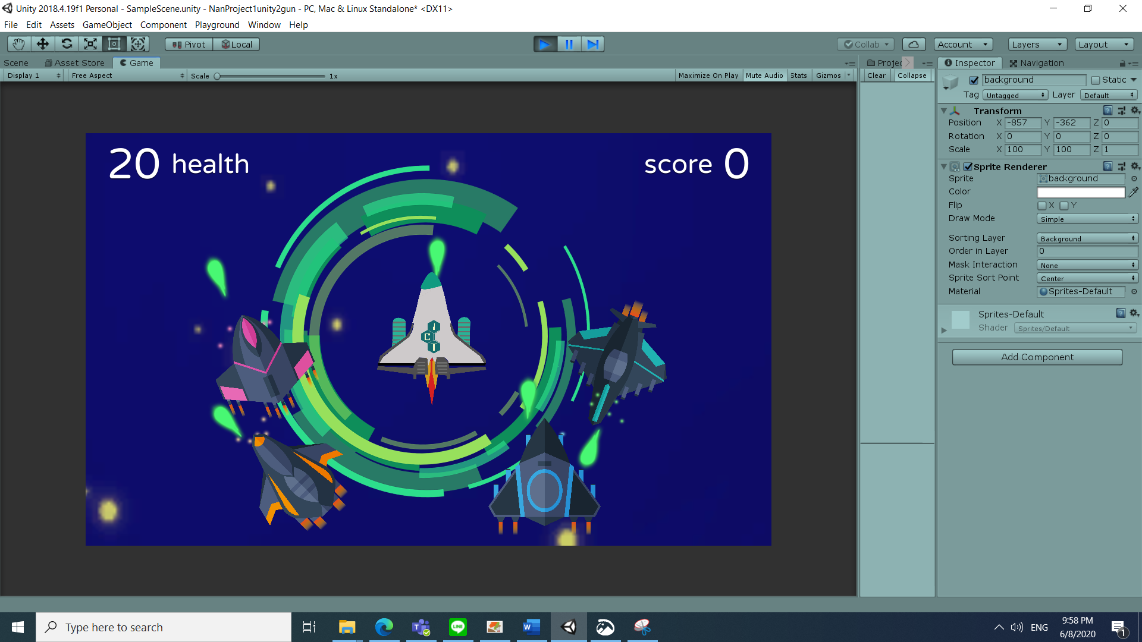

**Checkpoint 2: Playable area of at minimum 100x100**

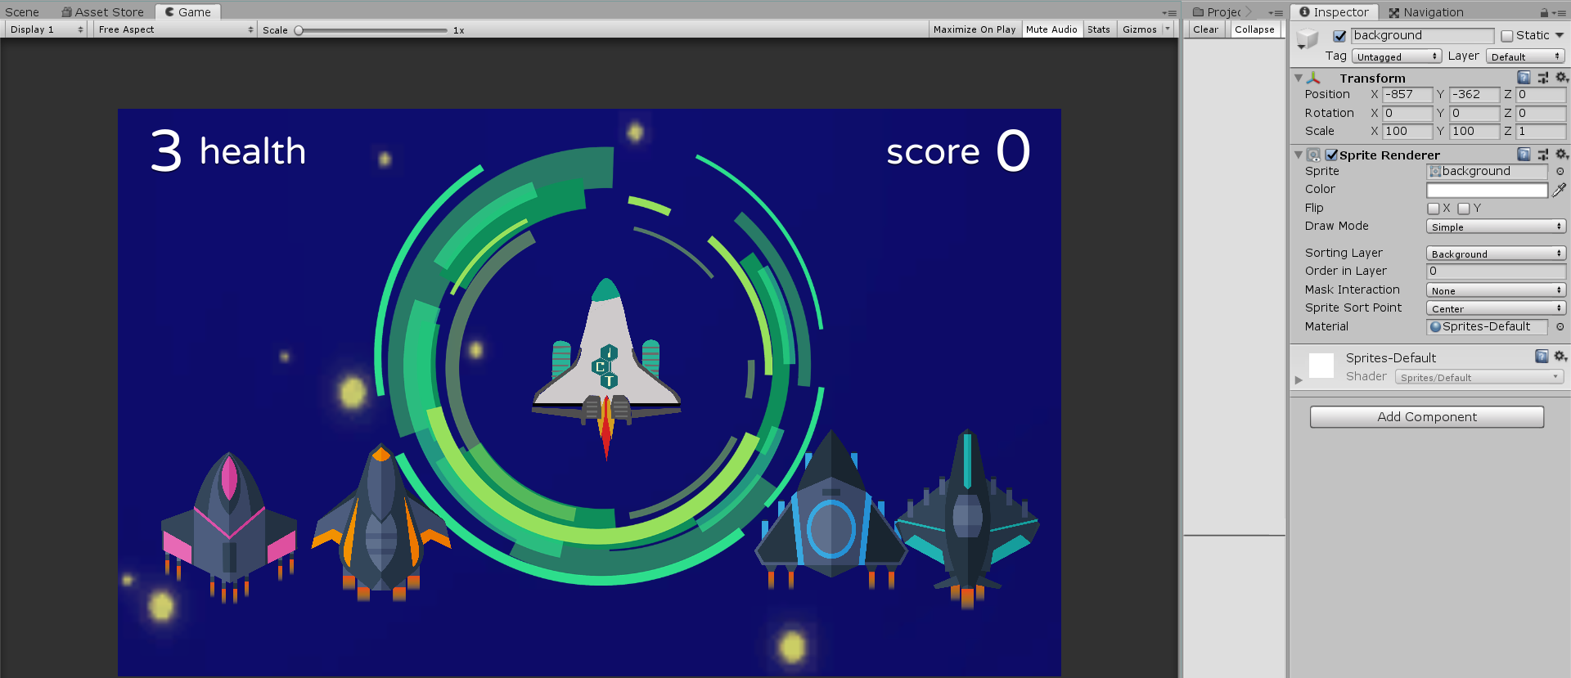

**Checkpoint 3: 10 types of solid obstacle**

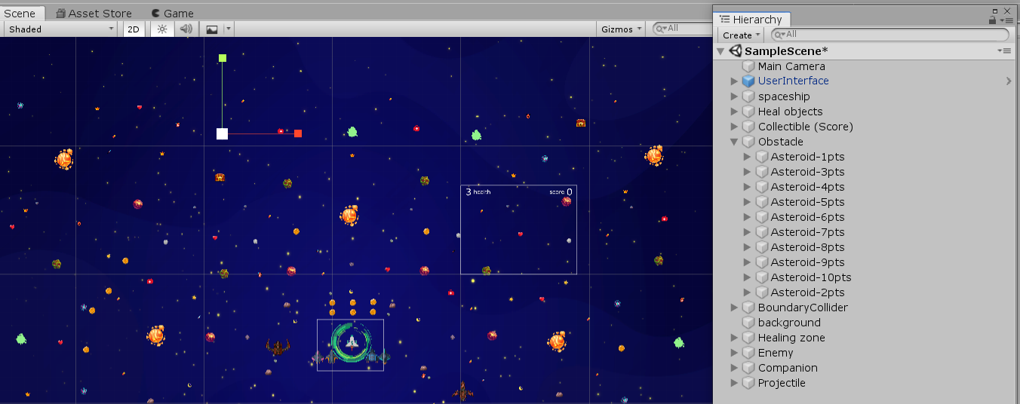

**Checkpoint 4: 5 types of touched-then-disappear object that heal players**

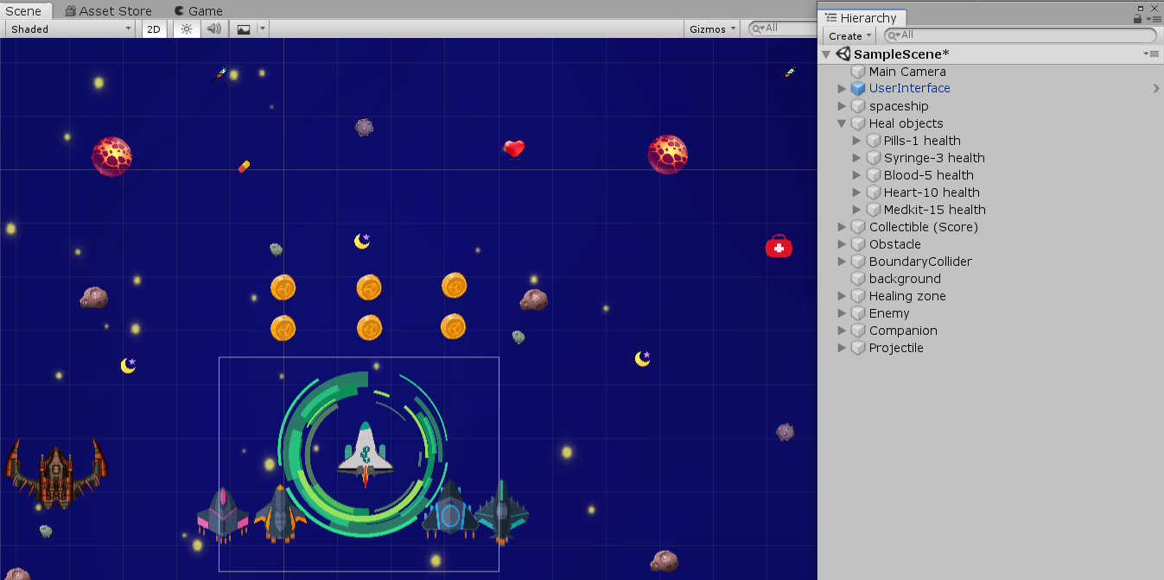

**Checkpoint 5: a healing zone that increases player health**

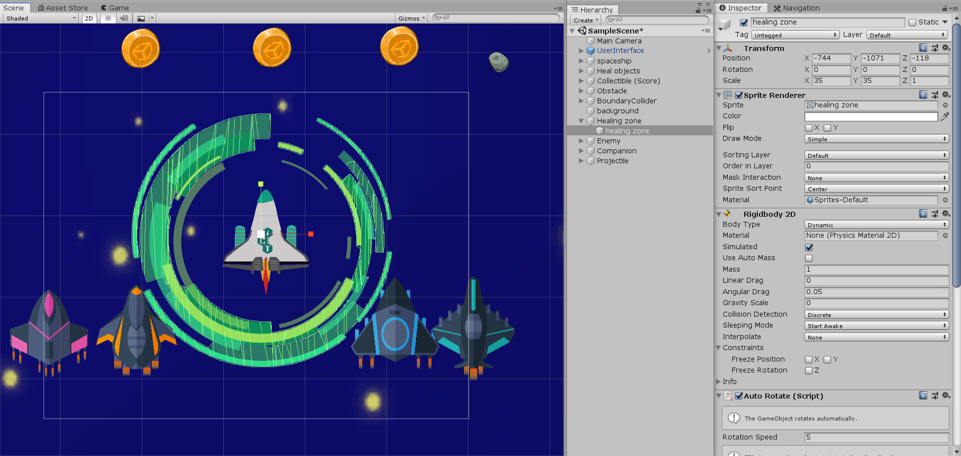

**Checkpoint 6: 5 types of score objects**

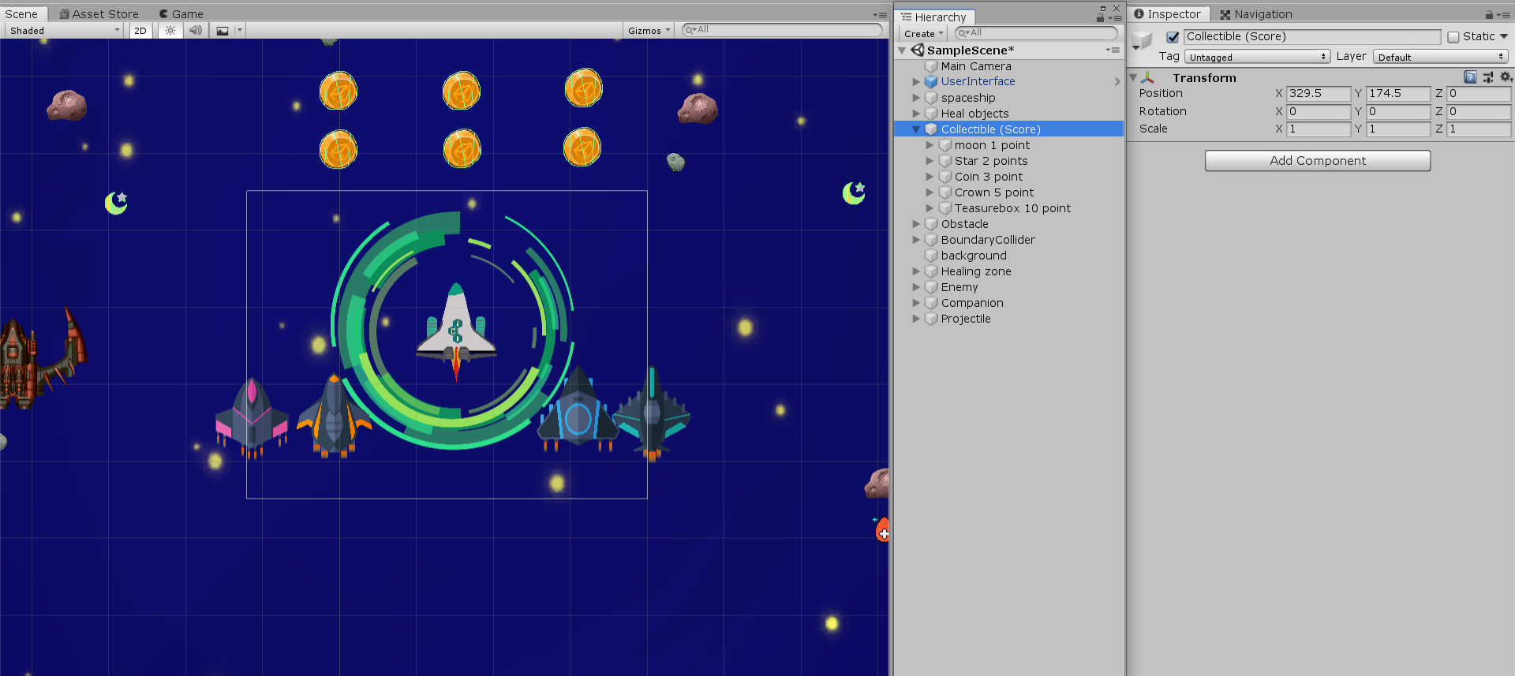

**Checkpoint 7: a new-game GUI button that allows player to restart**

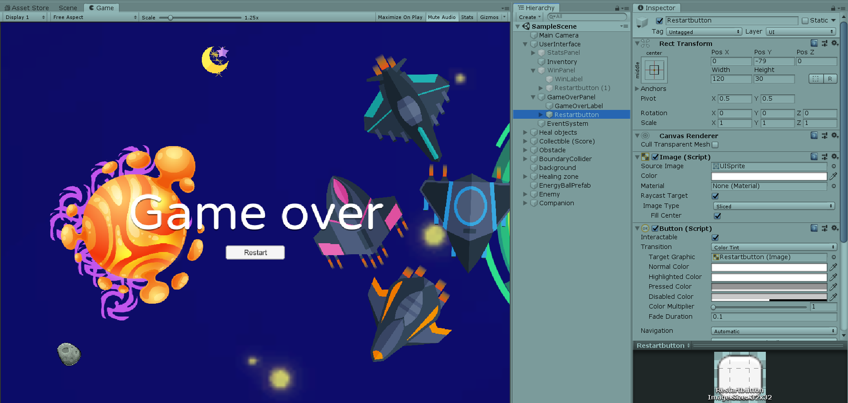

**Checkpoint 8:** **all features**

**1st Feature: Companion System**

We create the ally which consist of 4 companion spaceships. The ally will follow the player and help the player shoot the enemy.

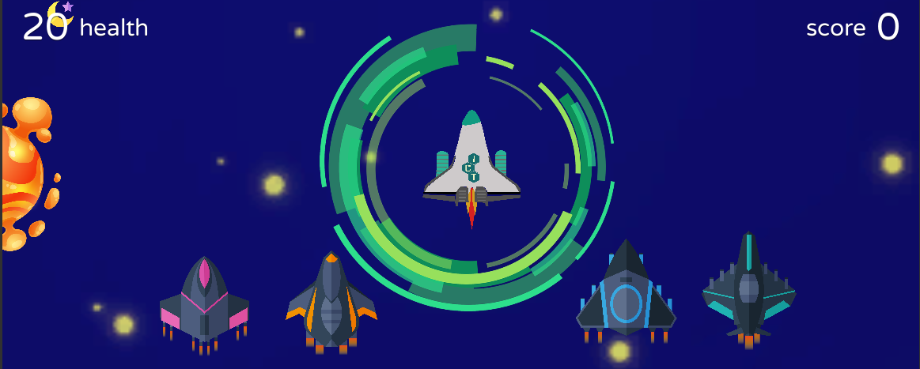

**2nd : Enemy and Enemy AI**

There are 4 boss enemies that will follow and aim to shoot the player in the space.

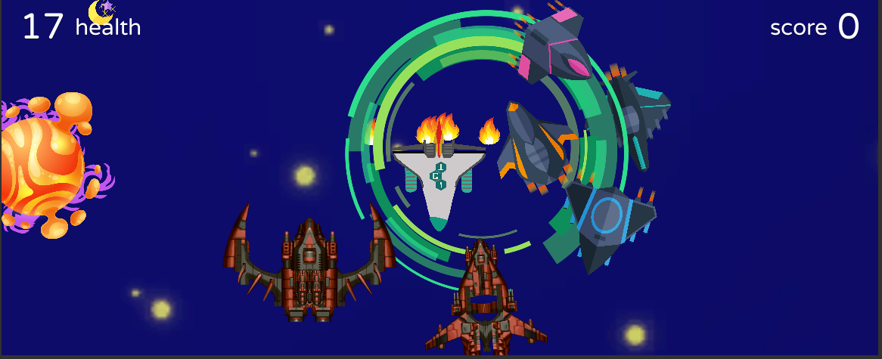

**3nd : Wining Condition of your own**

The player have to collect the collectible score to 20 to win the game.

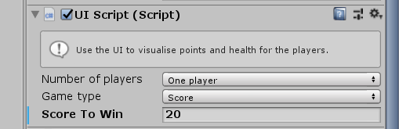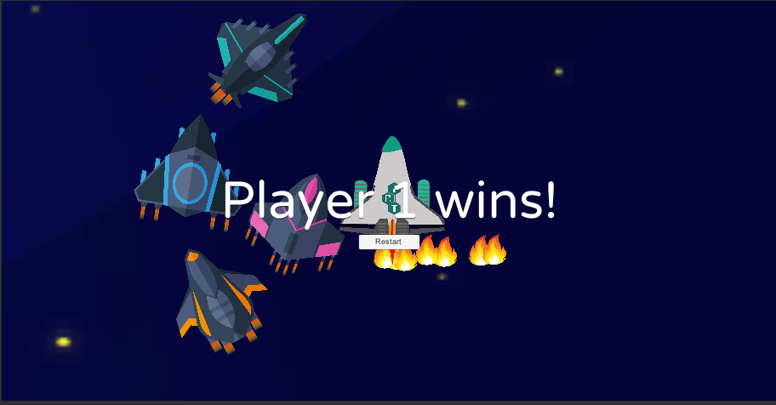

**4th Feature: Projectile Weapon System**

The player have the green projectile bullet to fight with the enemy.

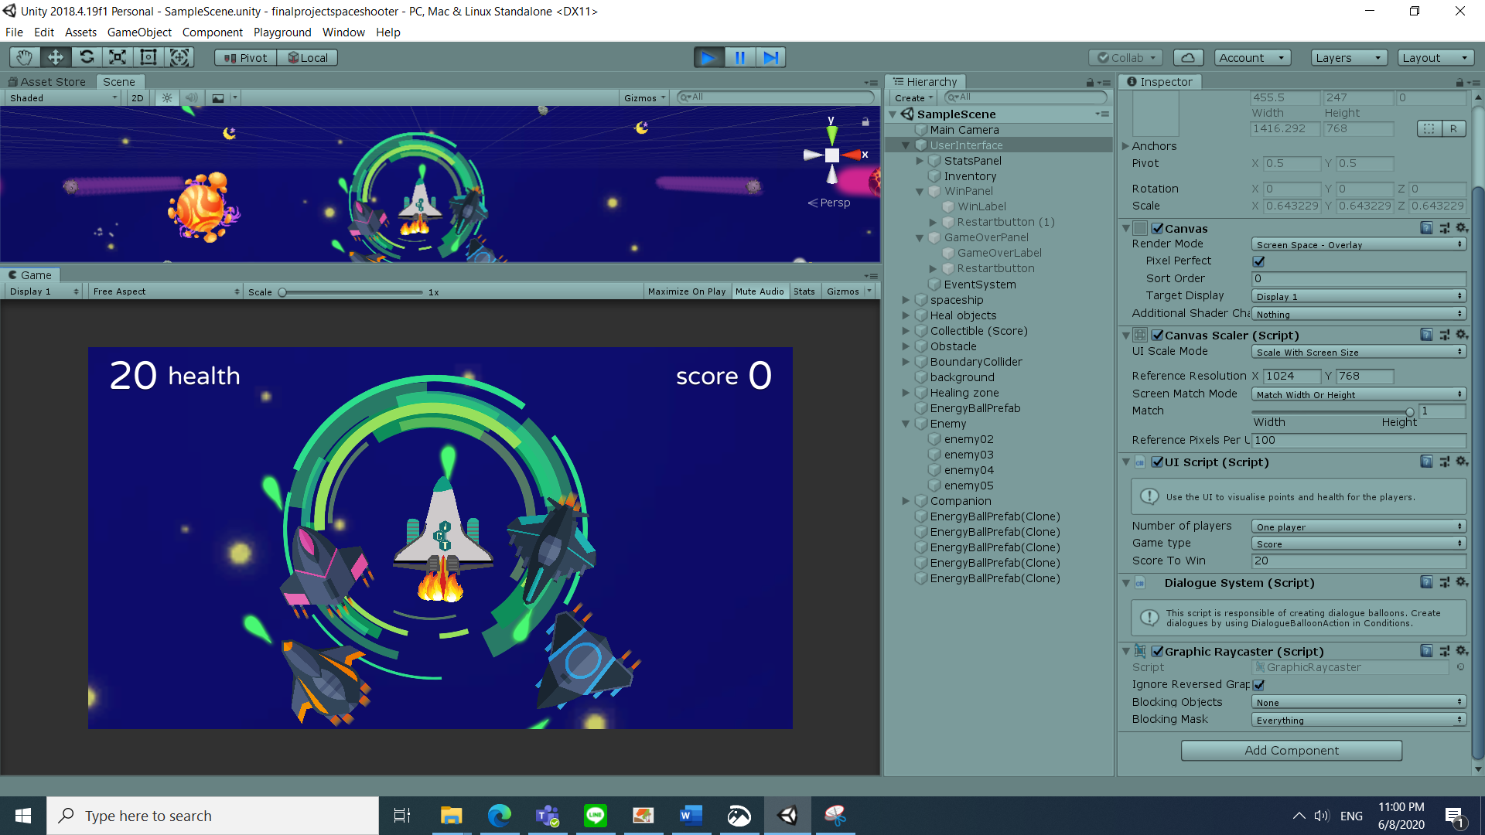

**5th Feature: VFX**

17 unique effects were create in space shooter game



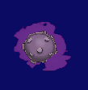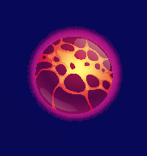

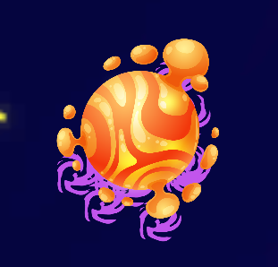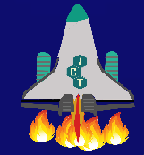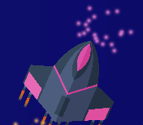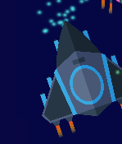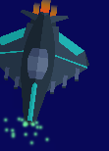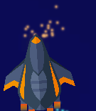

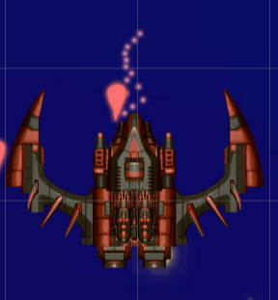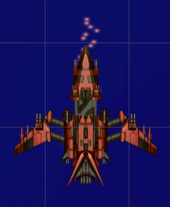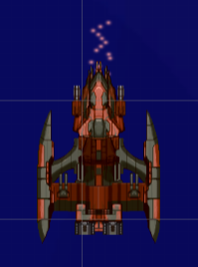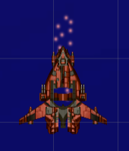

**6th Feature: Melee weapon**

The enemy have the secret melee weapon hidden in the body. There are not only the bully from the enemy can destroy the player, but also when the player touch the enemy, he will get the damage.

|  |  |  |  |  |  |  |  |
| --- | --- | --- | --- | --- | --- | --- | --- |
| Feature | Description | Base | T1 | T2 | T3 | T4 | T5 |
| Playable Game Level | Mandatory | 8% |  |  |  |  |  |
| Companion System (Level E : Variety of Ally) | Create more 3 types of Ally total that has its own state and its own weapon system and behave similarly | 1.5% | 3% |  |  |  |  |
| Enemy and Enemy AI (Level E : Variety of enemy) | Create more 3 types of Enemy total that has its own stat and its own weapon system and behave similarly | 1% | 3% |  |  |  |  |
| Winning Condition (Level base : Your own winning condition) | Implement your own design of wining condition and explain it in the document. | 1% |  |  |  |  |  |
| Malee weapon system (Level base) | The enemy have the secret malee weapon hidden in the body. When the player touch the enemy, he will get the damage. | 1.5% |  |  |  |  |  |
| Projectile Weapon System (Level base : Create your own unique projectile weapon system) | Create your own projectile system ( let say it is your unique way of a range weapon in the game) | 1.5% |  |  |  |  |  |
| VFX (Level SS : Effect with particle systems) | Create 17 unique effects | 1.5% | 2.5% | 3.5% | 4.5% | 5.5% | 6.5% |

Total score = 8 + 3 + 3 + 1 + 1.5 + 1.5 + 6.5

= 24.5